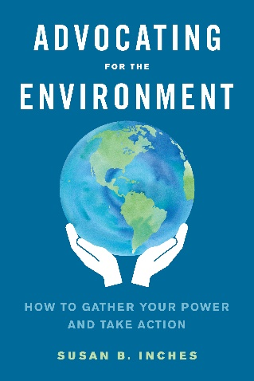

**A Complete Guide to Environmental Action!** *By Susan B. Inches, published by North Atlantic Books, 368 pages.*

Every week we are bombarded with reports, books and social media presenting the climate crisis as a dire threat, which it is. The problem is, few books offer ways to address it. *Advocating for the Environment,* was written to fill this gap, and shows ordinary people what they can do to impact climate policy. The book is upbeat, and accessible to people of all ages and backgrounds.

Part I of the book begins with how we must learn to think differently, in order to heal the planet. It lays out how empathy, worldviews, and effective communication can help us collaborate with others, even those with opposing views.

Part II is all about action. How to use power for good, how to work with decision makers, and how to create and manage a campaign are laid out in an easy to read and reference format. *Advocating for the* *Environment* is a guide to environmental action that readers will want to read and keep for reference, for years to come.

***Speaking Engagements and Workshops:***These presentations are available live and virtually. They can be formatted as keynote lectures, breakout sessions or longer hands-on workshops. I will work with you to customize these presentations to meet your needs.

1. Finding Hope in the Face of Climate Change
2. Advocacy in Action! The Campaign Workshop
3. Storytelling and the Art of Advocacy
4. Bridging the Left and the Right: Communicating Across the Great Divide.
5. Good News for the Environment: Promising Trends in Environmental Policy

***Book Clubs and Discussion Groups****:*Advocating for the Environment is an excellent book for book clubs. The author can provide discussion questions to groups that want to read the book on their own. She can also lead a six-eight week online discussion course, based on the book.

***Newsletter:***“Latest News from Sue Inches” is a free bi-monthly newsletter with one or two inspiring articles in each issue. Topics range from storytelling, to community building to clear explanations of environmental issues. Subscribe at www.sueinches.com.

***Course and Text Book:****Advocating for the Environment* has been used as a textbook in environmental studies and environmental policy courses at Colby, Bates, University of New England, and St. Lawrence University. Because of it’s clear prose and easy style, it’s also suitable for middle and high school students.

***About the Instructor:***Susan Inches has had a thirty year career in environmental policy, working as an organizer, program director, and environmental lobbyist. Signature issues she’s worked on include: fisheries management, renewable energy, land use planning, building and energy codes, environmental rights and energy democracy. The author has taught Advocating for the Environment to undergraduates for six years. Sue is a natural leader who loves to share what she’s learned with students!

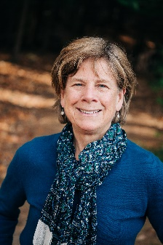

***More Information:****Advocating for the Environment* is available in ebook, audiobook and paperback. Get it at your local bookstore, from the author, or from Amazon.com.

Contact Sue: [sueinches@gmail.com](mailto:sueinches@gmail.com)  
Web: www.sueinches.com